GARAGE MANAGEMENT SYSTEM

College Name: CHIKKANNA GOVERNMENT ARTS COLLEGE

College Code:Bru06

TEAM ID: NM2025TMID26218

TEAM MEMBERS:

* Team Leader: Logendran M

Email: [logendranmarimuthu413@gmail.com](mailto:logendranmarimuthu413@gmail.com)

* Team Member: Deepsheka S

Email: [senthilnathandeepsheka@gmail.com](mailto:senthilnathandeepsheka@gmail.com)

* Team Member: Kaviyarsu V Email: [kaviyarasu3366@gmail.com](mailto:kaviyarasu3366@gmail.com)
* Team Member: Dhanush A Email: [dhanu464612@gmail.com](mailto:dhanu464612@gmail.com)

INTRODUCTION:

he Garage Management System is a valuable tool for automotive repair facilities, helping them deliver top-notch service, increase operational efficiency, and build lasting customer relationships. With its user-friendly interface and powerful features, GMS empowers garages to thrive in a competitive market while ensuring a seamless and satisfying experience for both customers and staff.

**Creating a developer org in salesforce:**

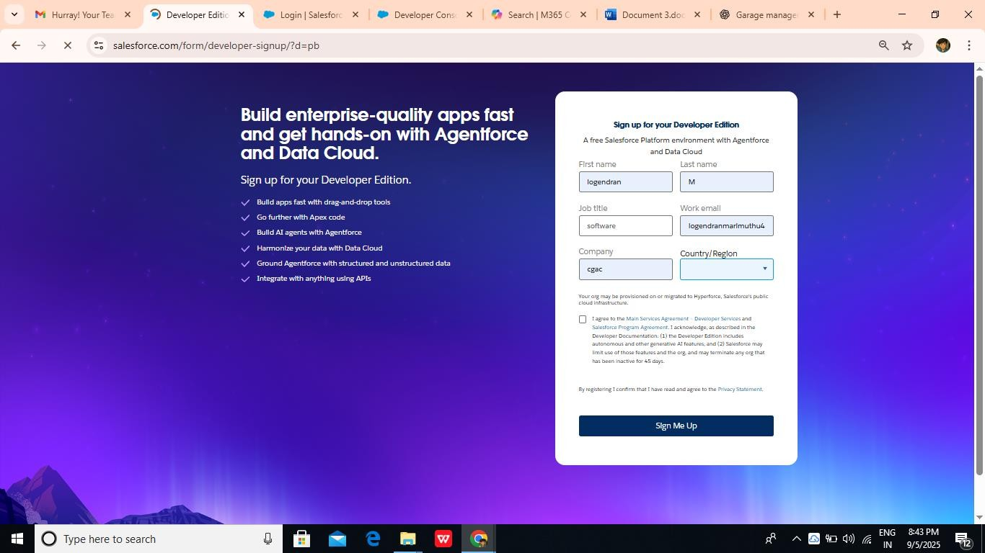

**create an object:**

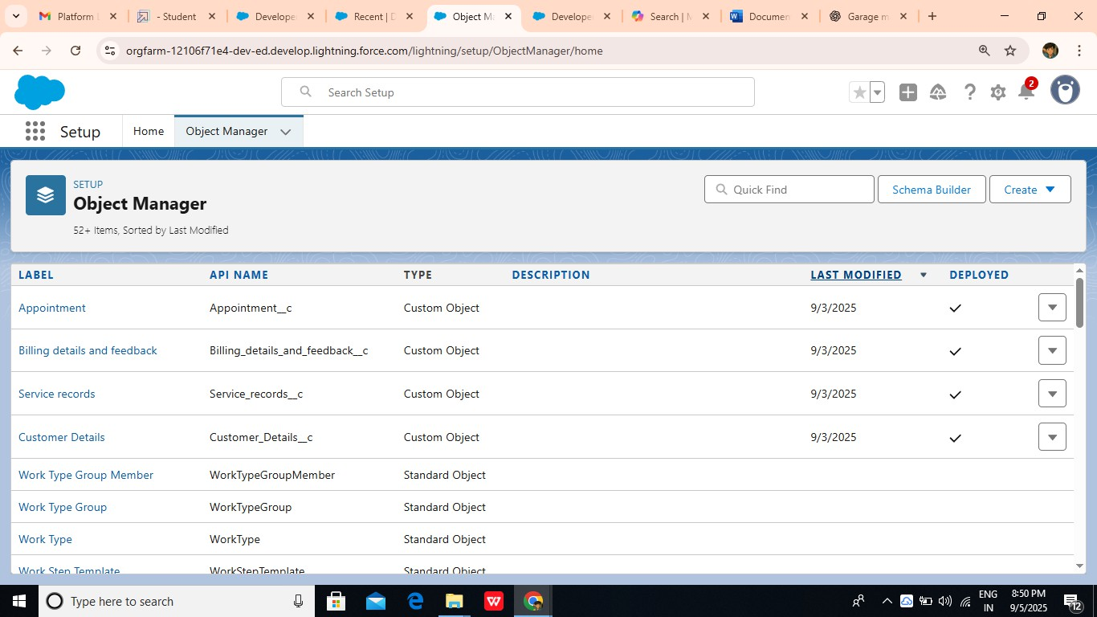

**create a Tab:(Customer Details)**

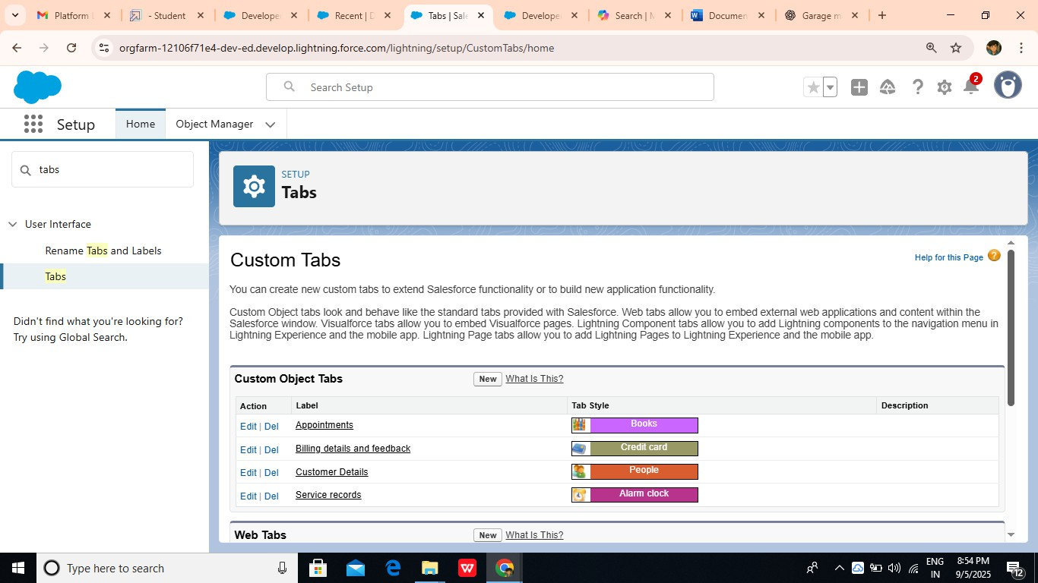

Create a Lightning App:

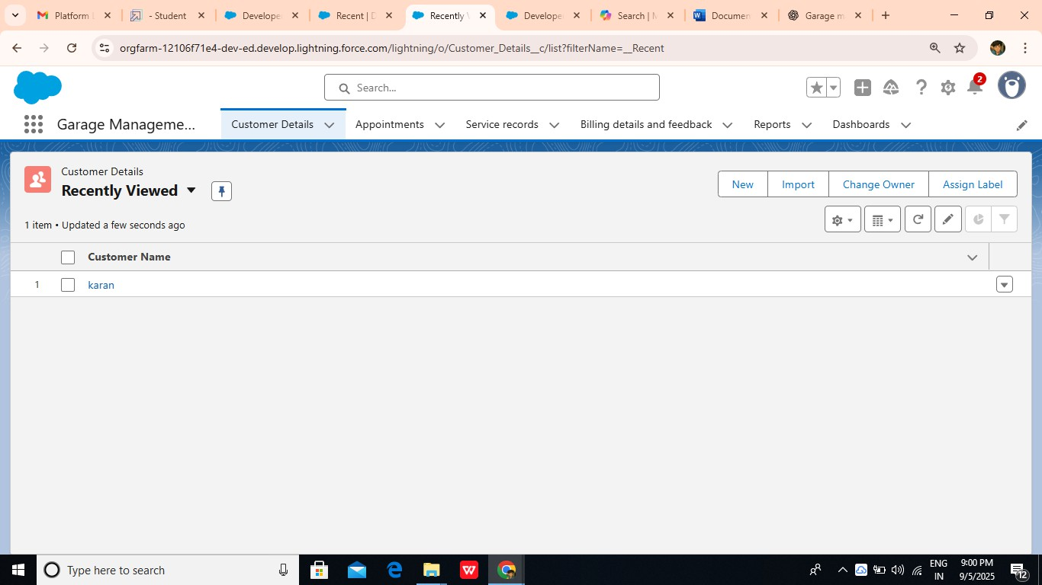

create fields in an object:

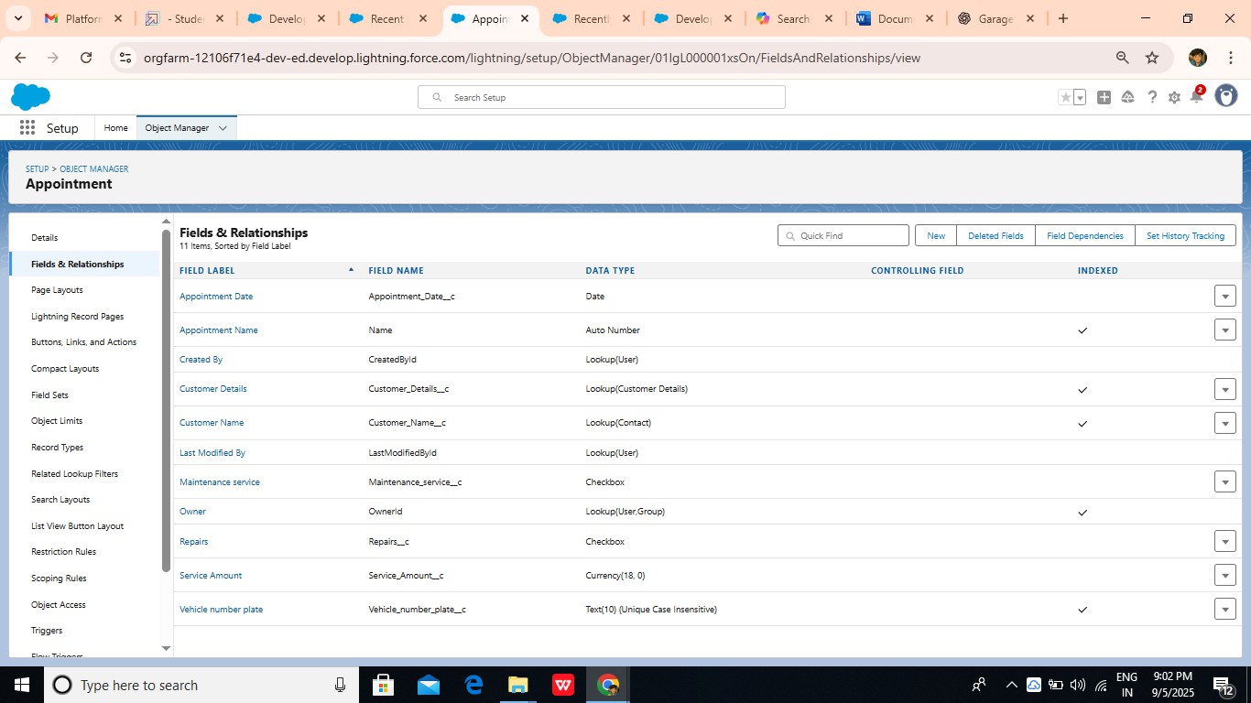

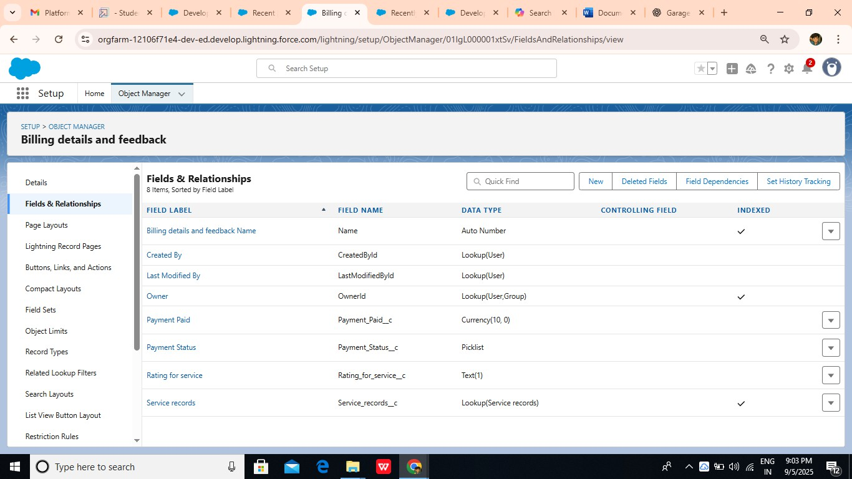

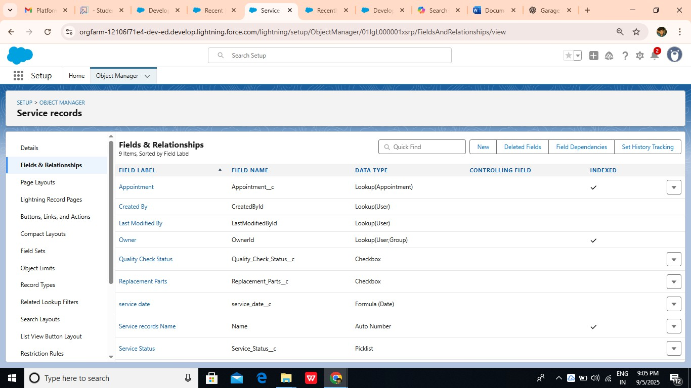

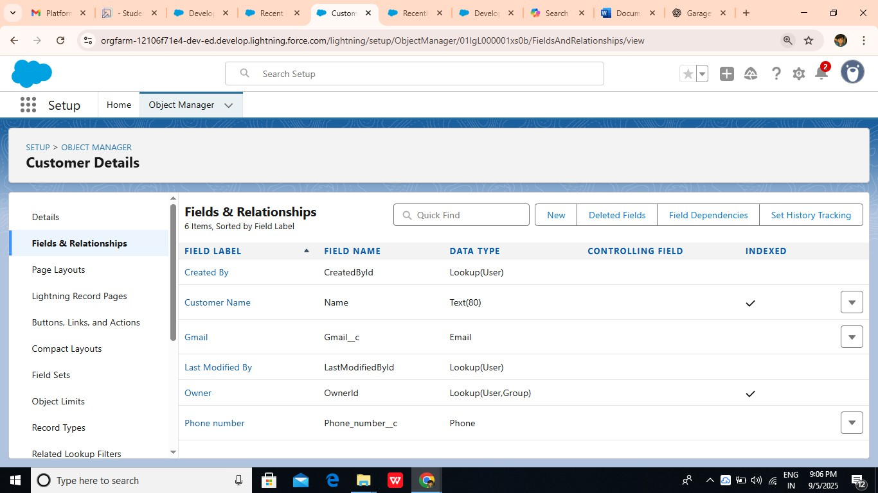

Create Validation rule:

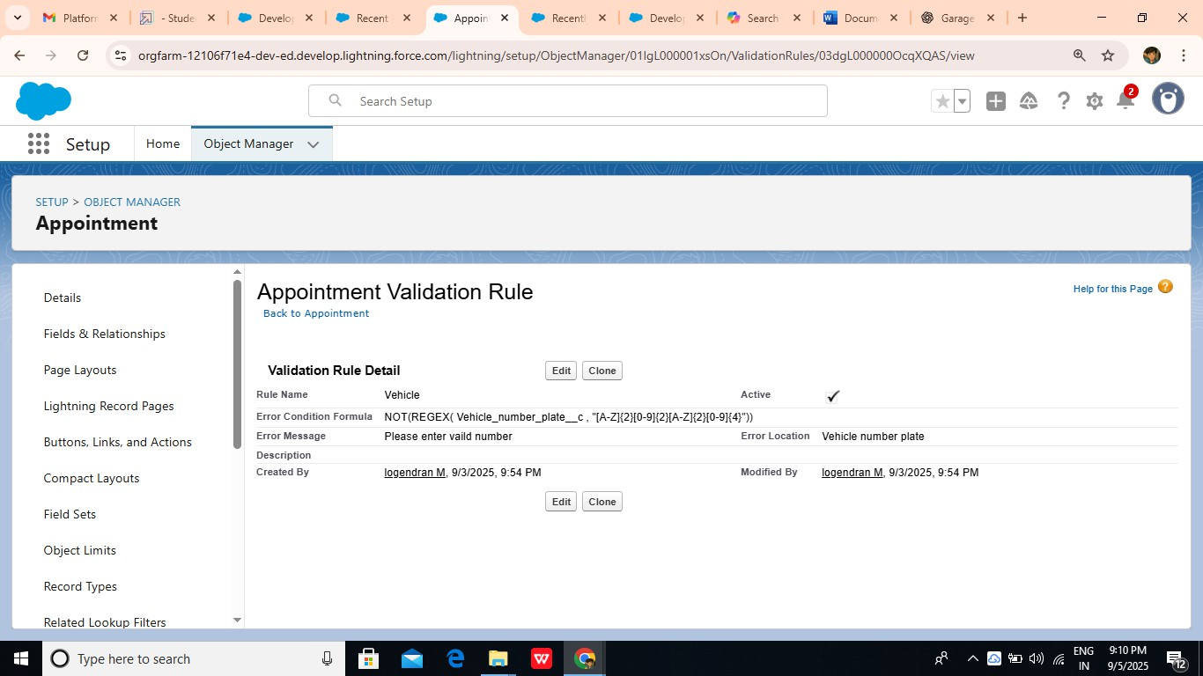

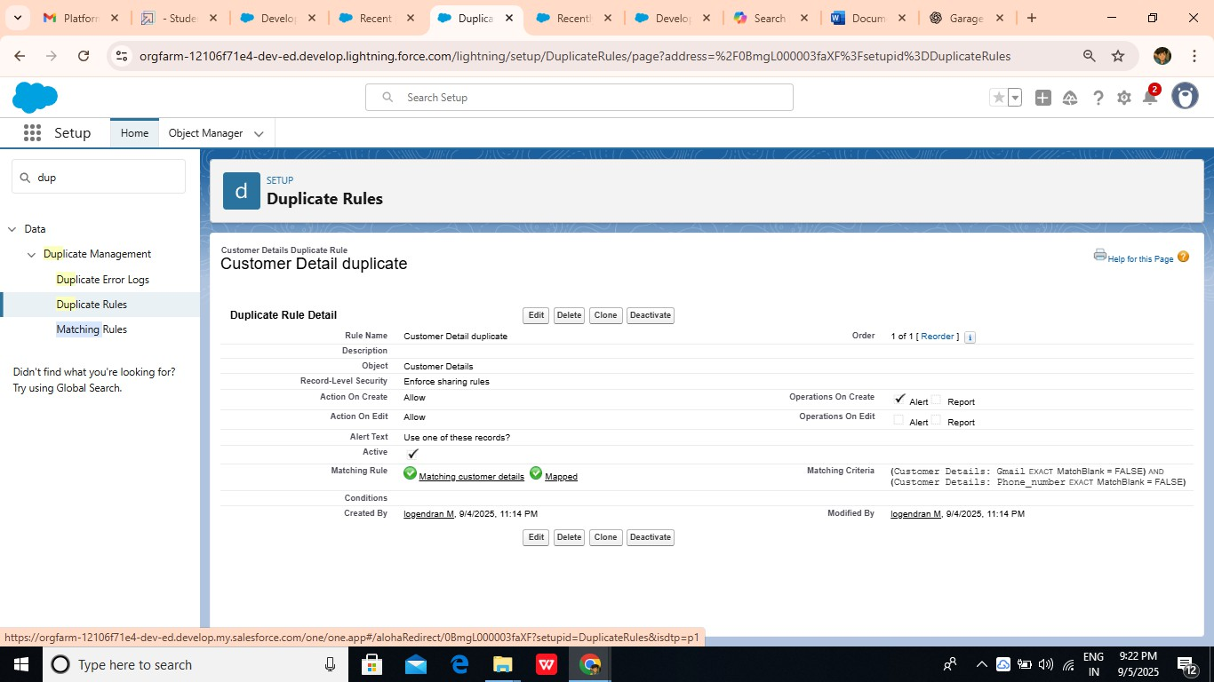

Duplicate rule to an Customer details Object:

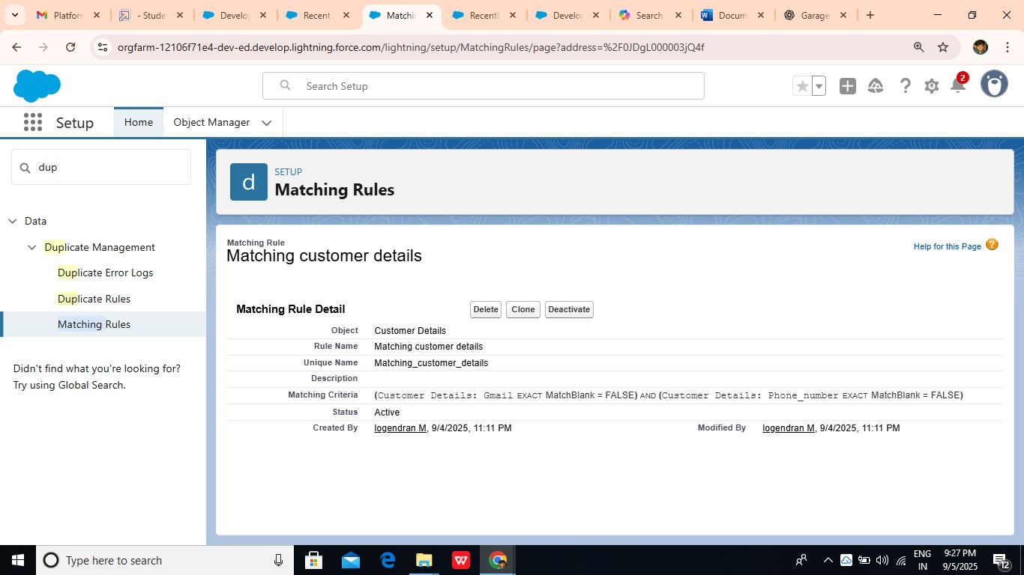

**Profiles:**

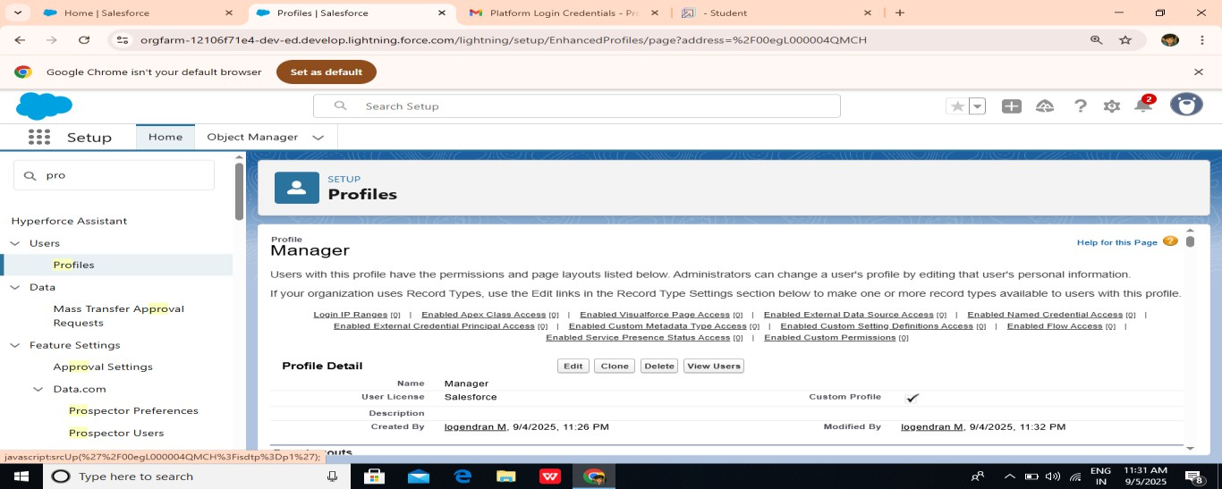

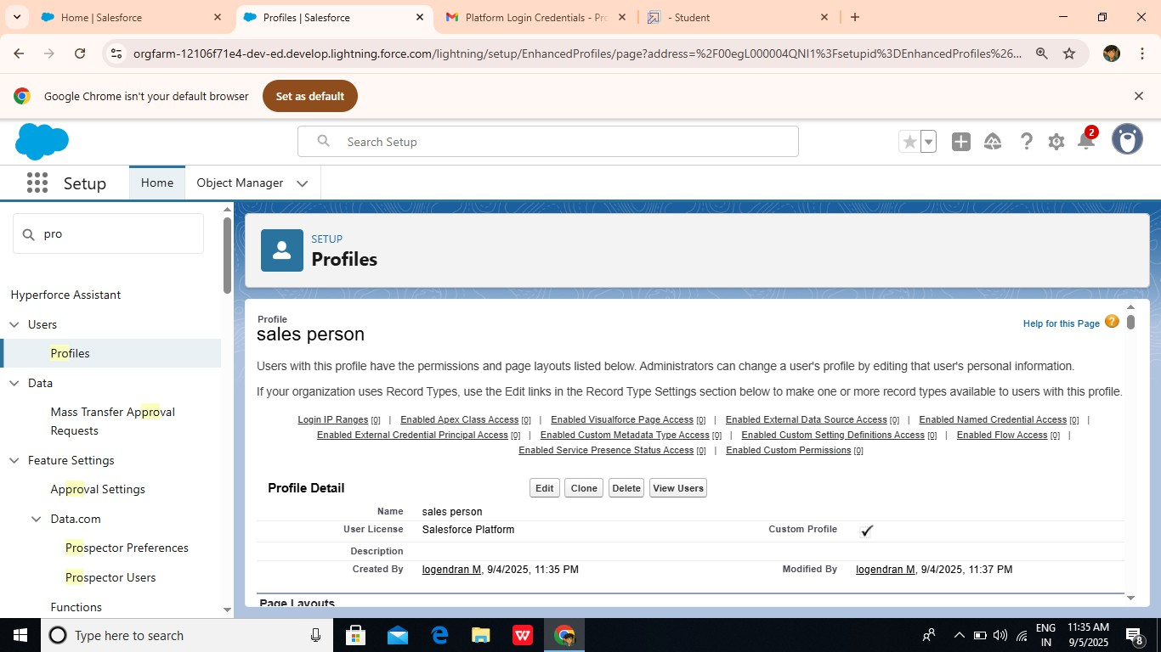

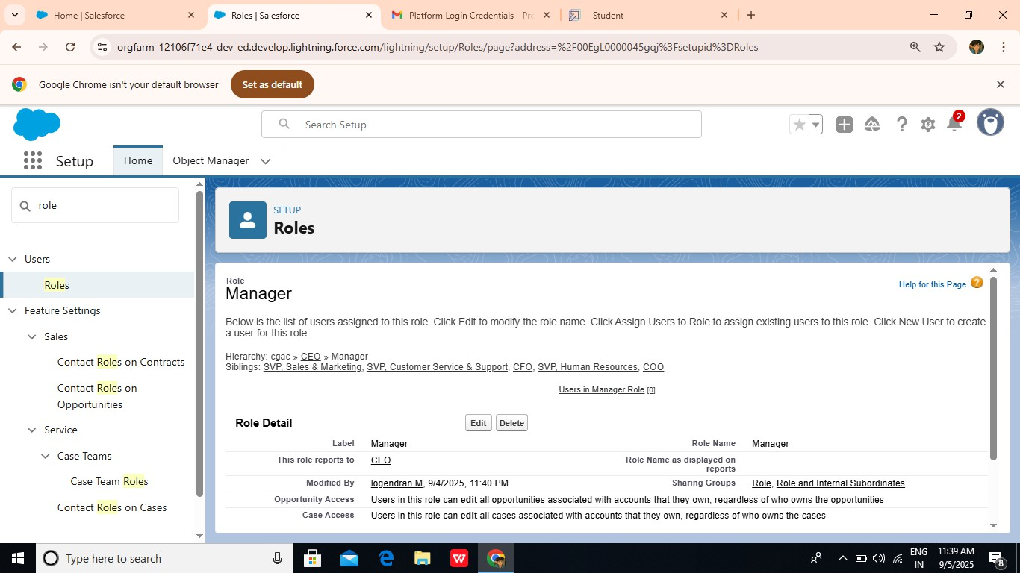Roles:

**User:**

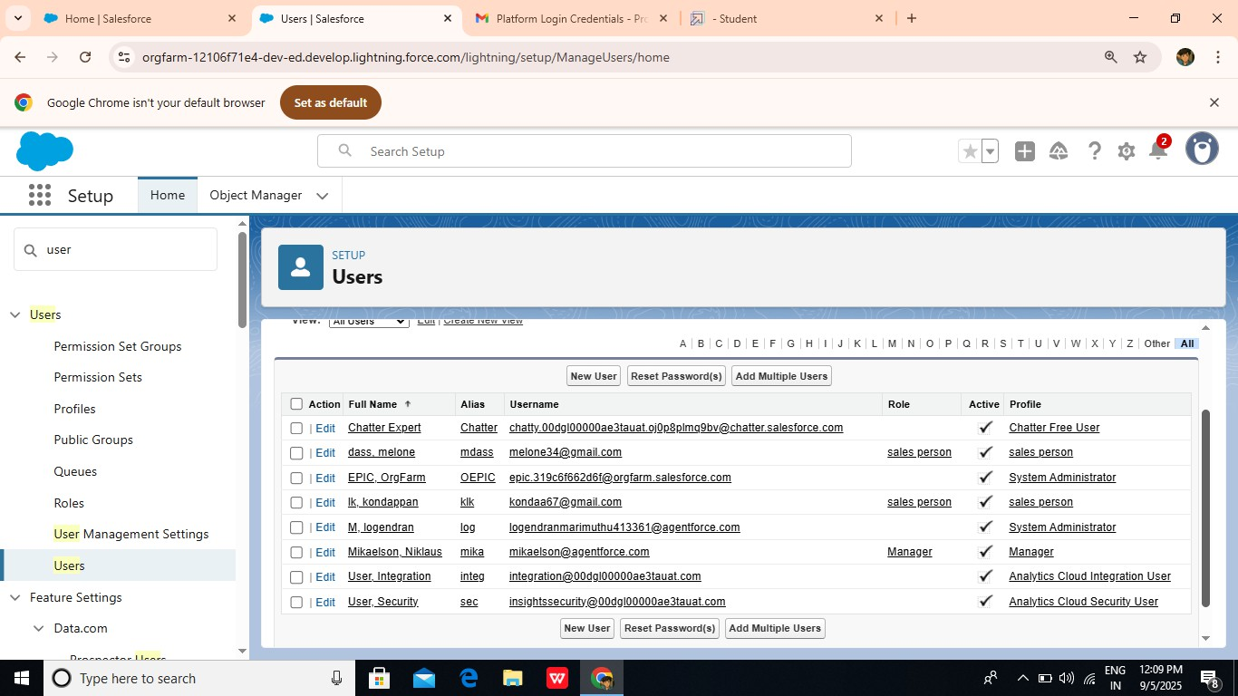

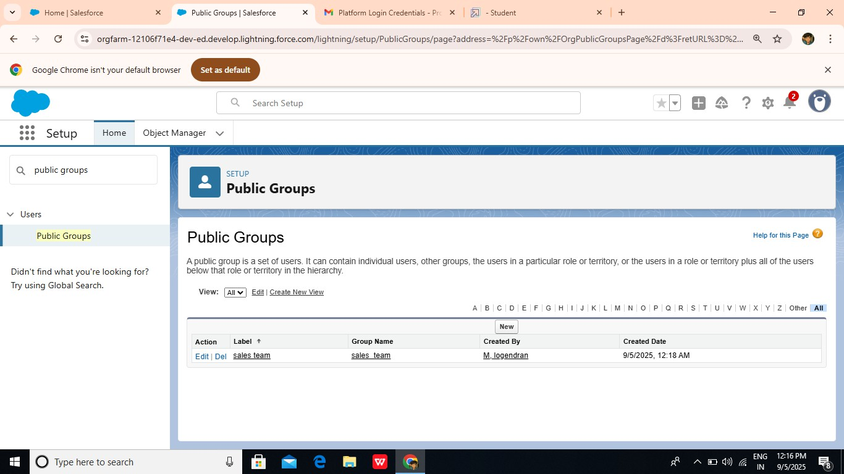

Sharing Setting:

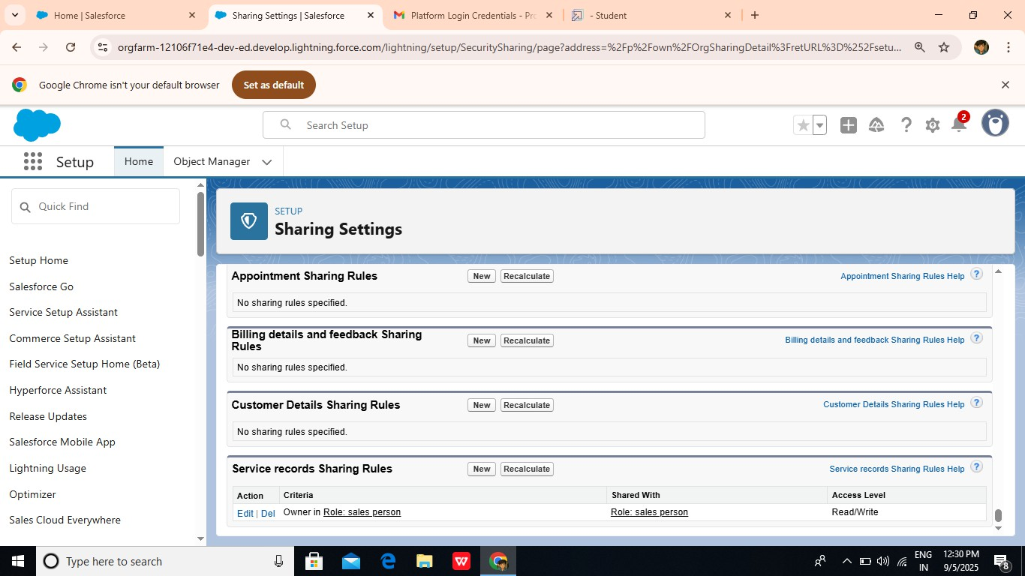

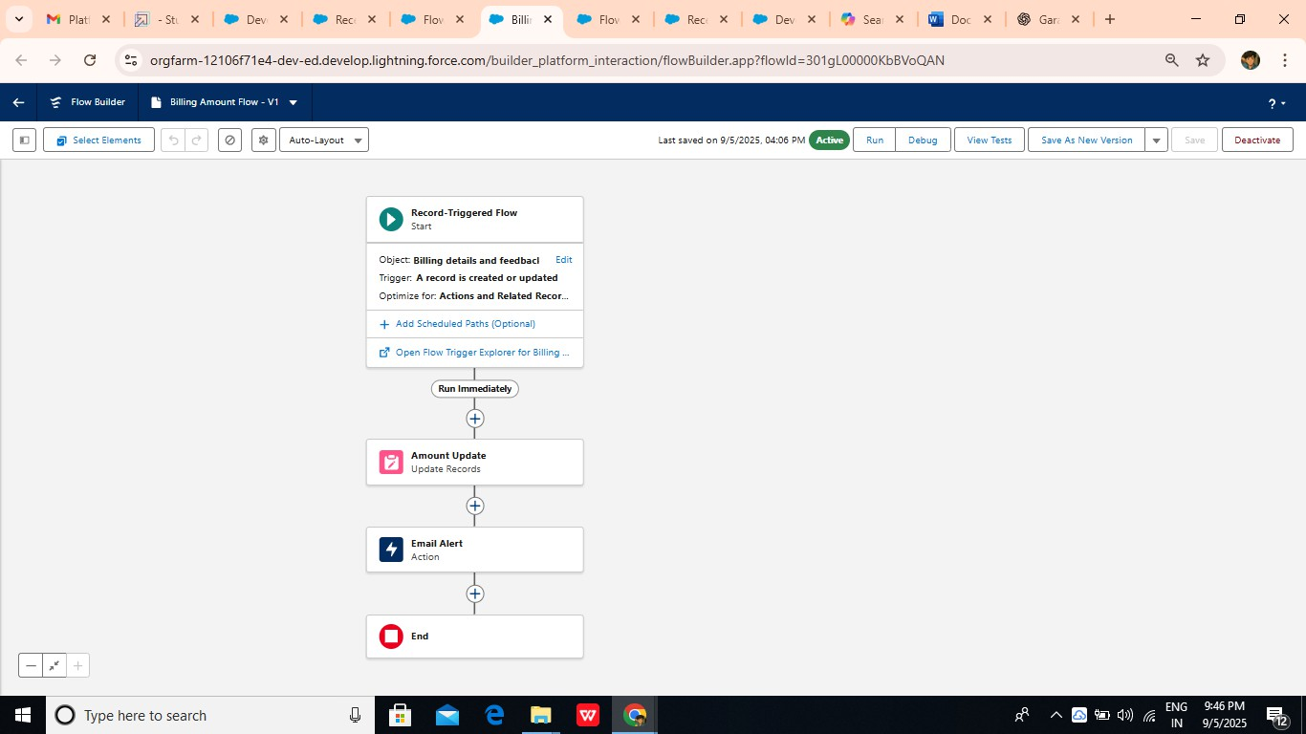Flows:

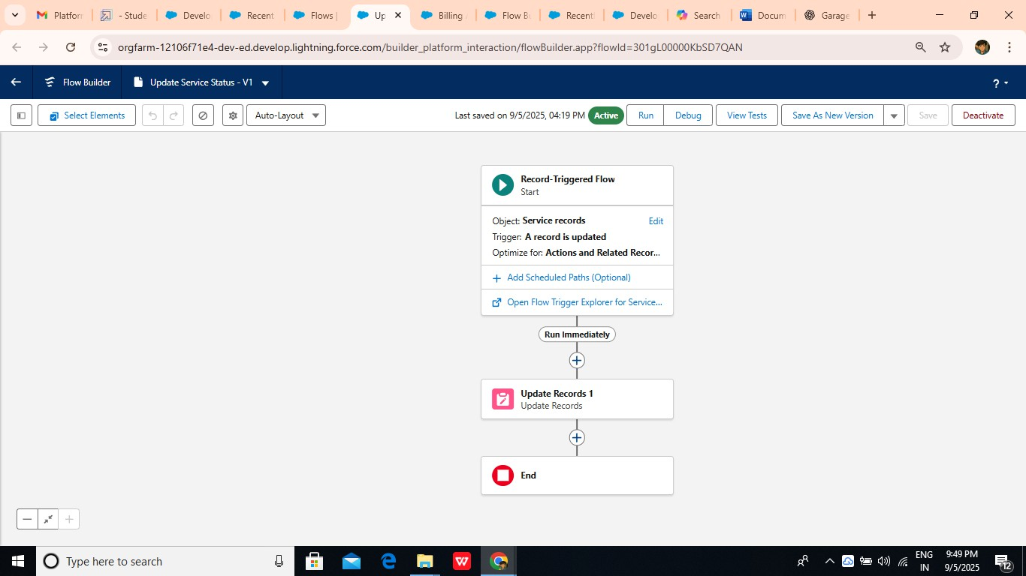

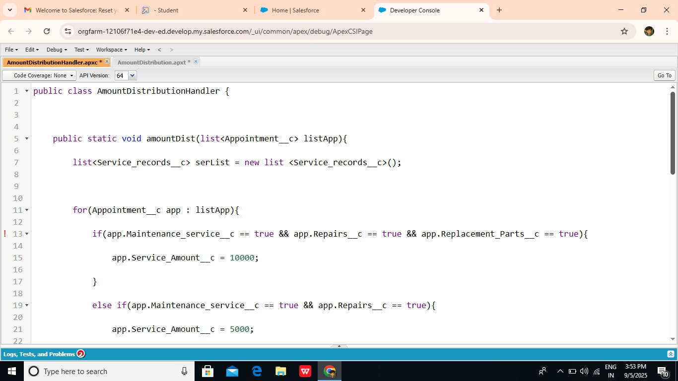Apex Trigger:

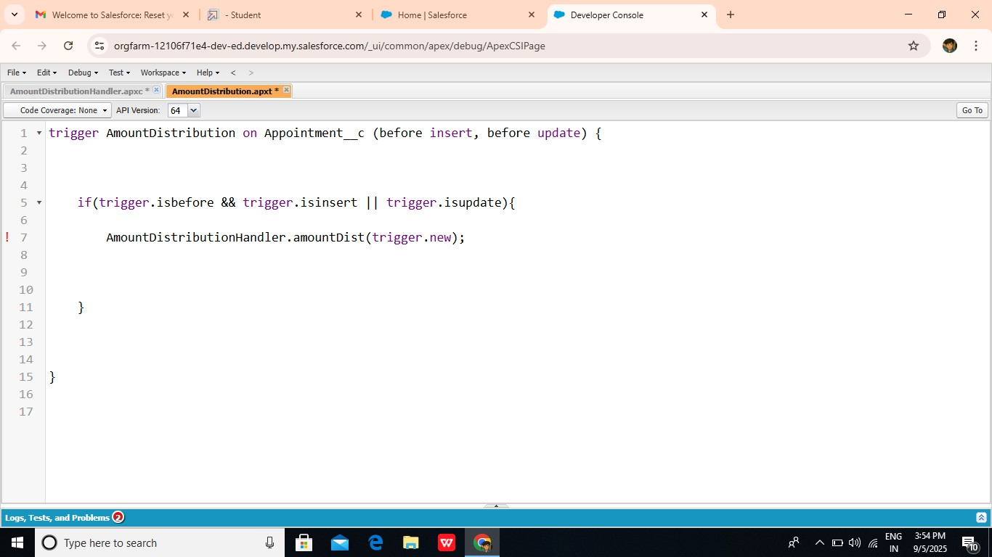

Reports:

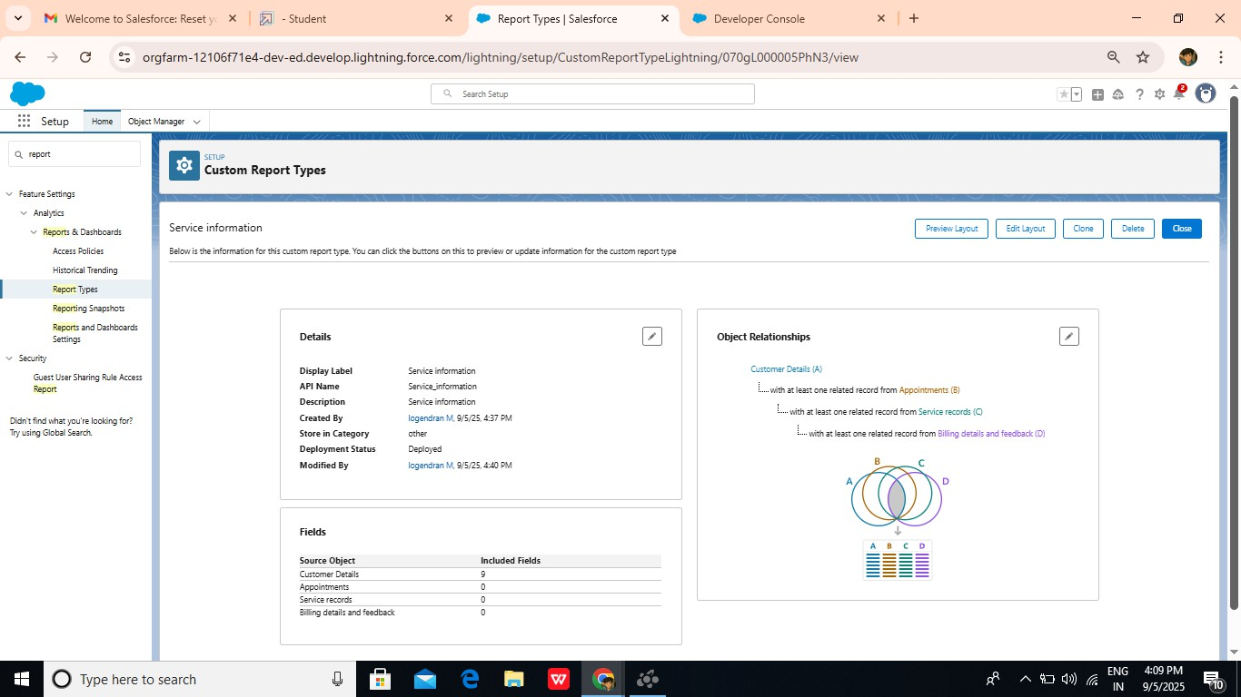

Dashboards:

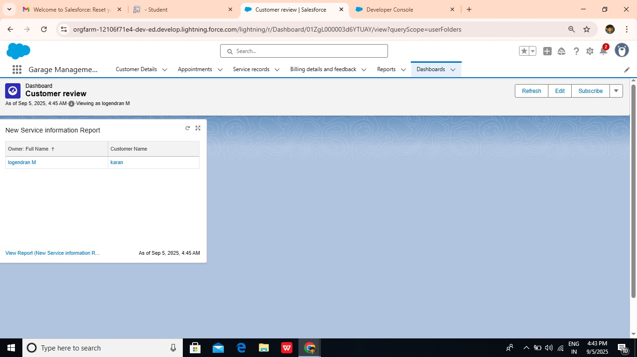

User adoption:

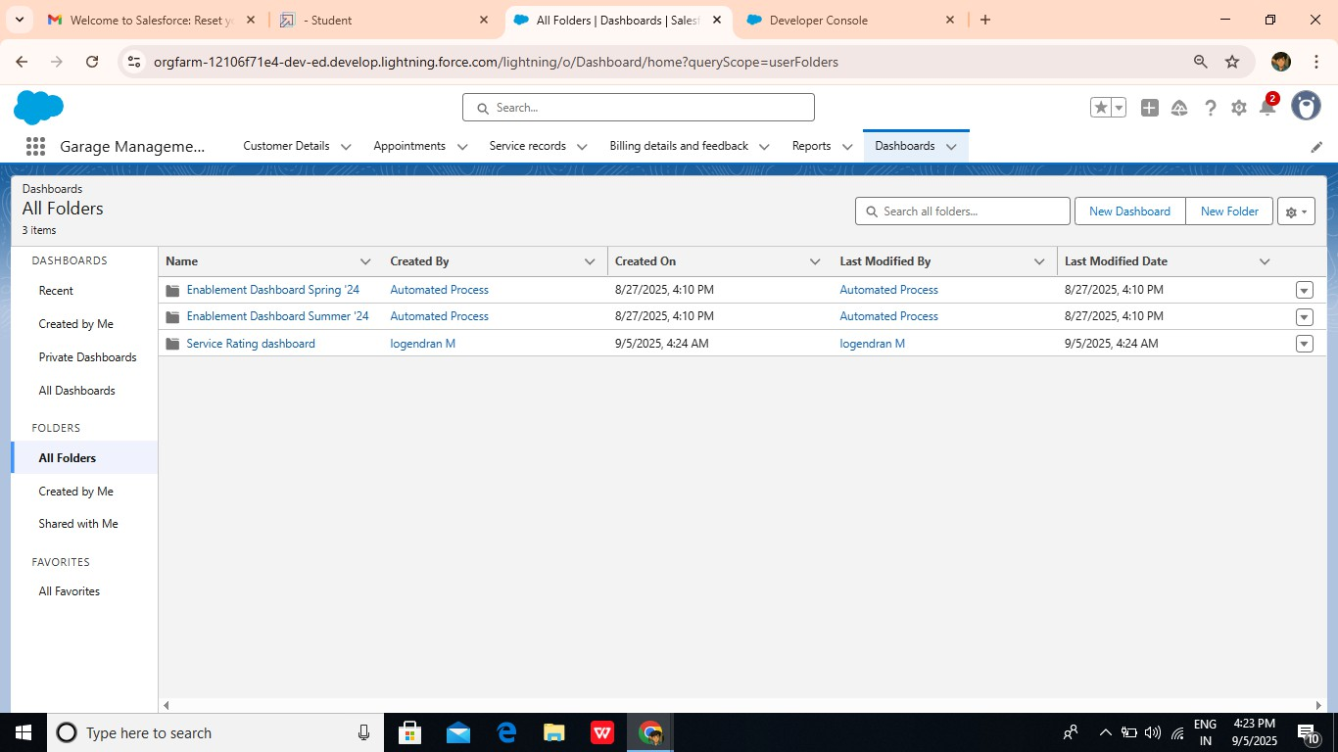

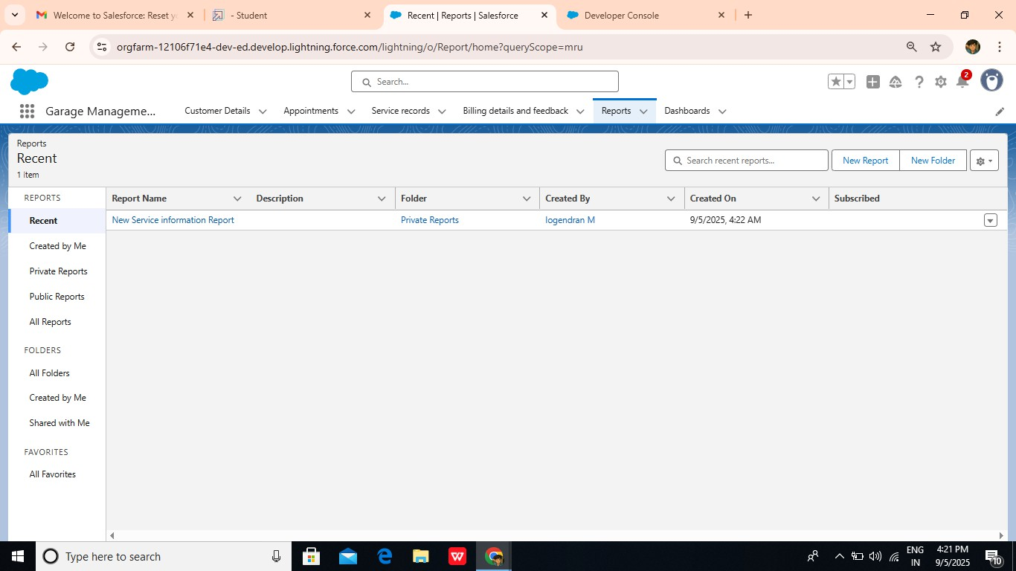

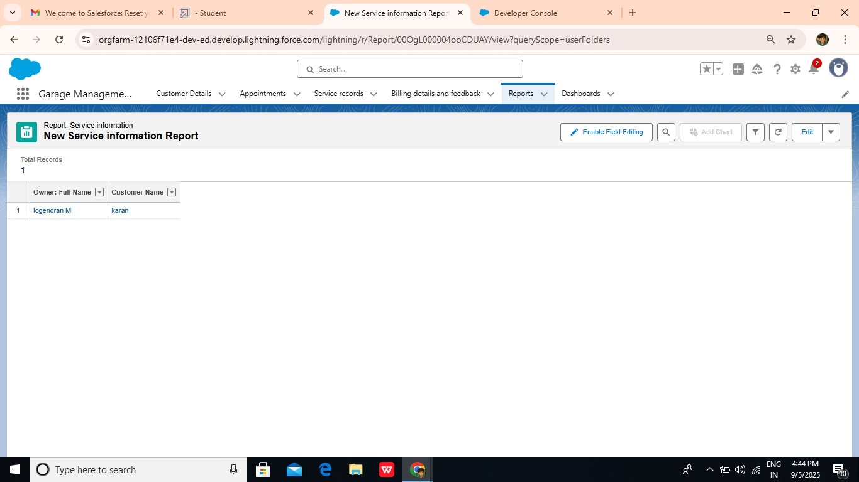



APPENDIX:

Amount distribution handler:

public class AmountDistributionHandler {

public static void amountDist(list<Appointment c> listApp){ list<Service_records c> serList = new list <Service_records c>();

for(Appointment c app : listApp){

if(app.Maintenance_service c == true && app.Repairs c == true && app.Replacement_Parts c == true){

app.Service_Amount c = 10000;

}

else if(app.Maintenance_service c == true && app.Repairs c == true){ app.Service_Amount c = 5000;

}

else if(app.Maintenance_service c == true && app.Replacement_Parts c == true){ app.Service_Amount c = 8000;

}

else if(app.Repairs c == true && app.Replacement_Parts c == true){ app.Service_Amount c = 7000;

}

else if(app.Maintenance_service c == true){ app.Service_Amount c = 2000;

}

else if(app.Repairs c == true){ app.Service_Amount c = 3000;

}

else if(app.Replacement_Parts c == true){ app.Service_Amount c = 5000;

}

}

}

}

Trigger Handler :

trigger AmountDistribution on Appointment c (before insert, before update) {

if(trigger.isbefore && trigger.isinsert || trigger.isupdate){ AmountDistributionHandler.amountDist(trigger.new);

}

}

CONCLUSION:

The **Garage Management System (GMS)**, built on the **Salesforce platform**, is a powerful and scalable solution designed to streamline the operations of automotive service centers. By leveraging **Salesforce’s robust CRM capabilities**, the system not only optimizes internal workflows such as **service booking, work order management, inventory tracking**, and **billing**, but also enhances the **customer experience** through real-time engagement via portals, notifications, and self-service options.